PIZZA SALES SQL QUERIES

**A.KPI’s**

**1. Total Revenue:**

SELECT SUM(total_price)AS Total_Revenue from pizza_sales;

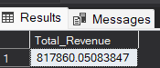

**2. Average Order Values:**

SELECT SUM(total_price) / COUNT(DISTINCT order_id) AS Avg_Order_Value from pizza_sales;

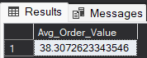

**3.Total Pizza Sold:**

SELECT SUM(quantity) AS Total_Pizza_Sold from pizza_sales;

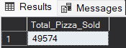

**4. Total Orders:**

SELECT COUNT(DISTINCT order_id) AS Total_Orders from pizza_sales;

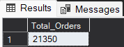

**5.Average Pizzas Per Order:**

SELECT CAST(CAST(SUM(quantity) AS decimal(10,2))/

CAST(COUNT(DISTINCT order_id) AS decimal(10,2)) AS decimal(10,2))

AS Avg_Pizzas_Per_Order from pizza_sales;

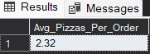

**B. Daily Trend for total Orders:**

SELECT DATENAME(DW, order_date) as order_day,COUNT(DISTINCT order_id)AS Total_orders from pizza_salesGROUP BY DATENAME(DW, order_date);

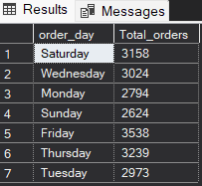

**C. Hourly Trend for Total Orders:**

SELECT DATEPART(HOUR, order_time) as Order_hours,COUNT(DISTINCT order_id)AS Total_orders

FROM pizza_sales

GROUP BY DATEPART(HOUR, order_time)

ORDER BY DATEPART(HOUR, order_time);

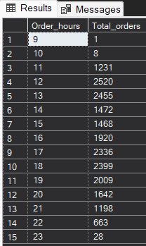

**D. Percentage of Sales by Pizza Category:**

SELECT pizza_category, CAST(SUM(total_price) AS DECIMAL(10,2)) as total_revenue,

CAST(SUM(total_price) * 100 / (SELECT SUM(total_price) from pizza_sales) AS DECIMAL(10,2)) AS PCT

FROM pizza_sales

GROUP BY pizza_category

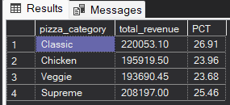

**E. % of Sales by Pizza Size**

SELECT pizza_size, CAST(SUM(total_price) AS DECIMAL(10,2)) as total_revenue,

CAST(SUM(total_price) * 100 / (SELECT SUM(total_price) from pizza_sales) AS DECIMAL(10,2)) AS PCT

FROM pizza_sales

GROUP BY pizza_size

ORDER BY pizza_size

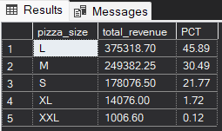

**F. Total Pizzas Sold by Pizza Category**

SELECT pizza_category, SUM(quantity) as Total_Quantity_Sold

FROM pizza_sales

GROUP BY pizza_category

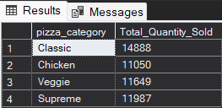

**G. Top 5 Best Sellers by Total Pizzas Sold**

SELECT Top 5 pizza_name, SUM(quantity) AS Total_Pizza_Sold

FROM pizza_sales

GROUP BY pizza_name

ORDER BY Total_Pizza_Sold DESC

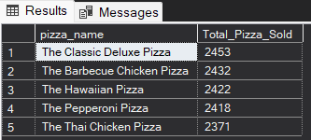

**H. Bottom 5 Best Sellers by Total Pizzas Sold**

SELECT TOP 5 pizza_name, SUM(quantity) AS Total_Pizza_Sold

FROM pizza_sales

GROUP BY pizza_name

ORDER BY Total_Pizza_Sold ASC

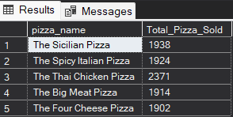

***NOTE***

If you want to apply the Month, Quarter, Week filters to the above queries you can use WHERE clause. Follow some of below examples

SELECT DATENAME(DW, order_date) AS order_day, COUNT(DISTINCT order_id) AS total_orders

FROM pizza_sales

WHERE MONTH(order_date) = 1

GROUP BY DATENAME(DW, order_date)

*\*Here MONTH(order_date) = 1 indicates that the output is for the month of January. MONTH(order_date) = 4 indicates output for Month of April.*

SELECT DATENAME(DW, order_date) AS order_day, COUNT(DISTINCT order_id) AS total_orders

FROM pizza_sales

WHERE DATEPART(QUARTER, order_date) = 1

GROUP BY DATENAME(DW, order_date)

*\*Here DATEPART(QUARTER, order_date) = 1 indicates that the output is for the Quarter 1. MONTH(order_date) = 3 indicates output for Quarter 3.*